Assignment-1

Connect and disconnect with login Access

* What happens when you login a non-existent users or username?
  + Provide Screenshot and What you understand, explain in short brief?

Ans. - Didn’t got the question.

Assignment-2

Password changing

* Login into your account and then change password?
  + Change your password into ***IneuR0n#42*** and hit the **Enter** key
    - Explain what happen and give screenshot?

Ans - Password succesfully changed with no error.

* Try again to change password but use like password ***1234*** or ***abcd***
  + Explain what happen and give screenshot?

Ans.- Its asking to add more number, letter and punctuation.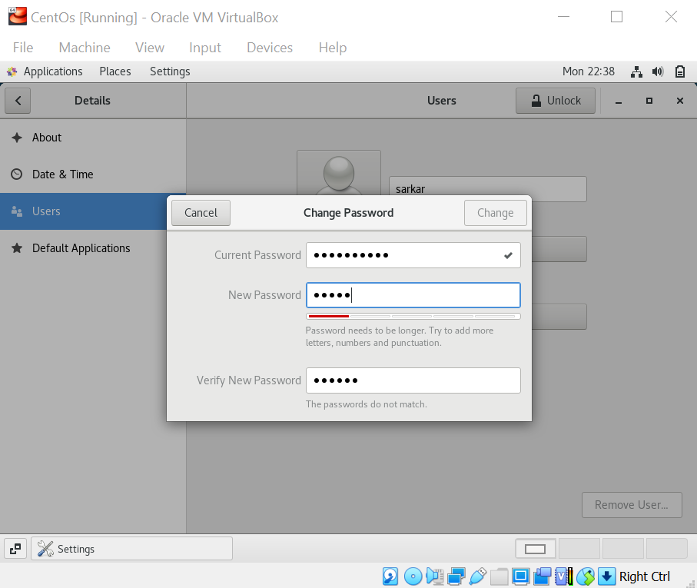

* Try again to change password but now don’t use any password just hit **Enter** key
  + Explain what happen and give screenshot?

Ans – Nothing is happening it just closing that tab and older remain constant i.e IneuR0n#42.

Assignment-3

Working with Directories

* Enter the command **cd /** and then **ls** and then hit **Enter** key
  + Take screenshot and explain what output we got?

Ans – By given cd / command we enter into root directory and by giving ls command we see the list of folders inside root directory.

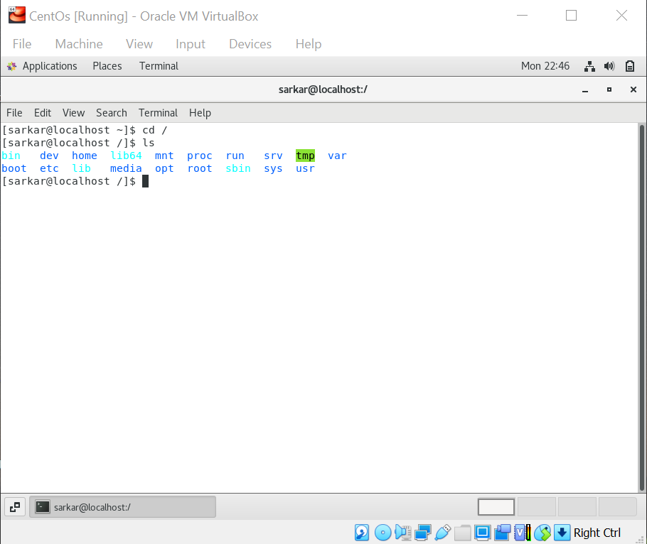

* Enter the command now **cd /home** and then hit **Enter** key

Do **ls,** provide screenshot and explain what is **/home** directory used for?

Ans.- /home command is used to enter home tab, where we can find our user named folder.

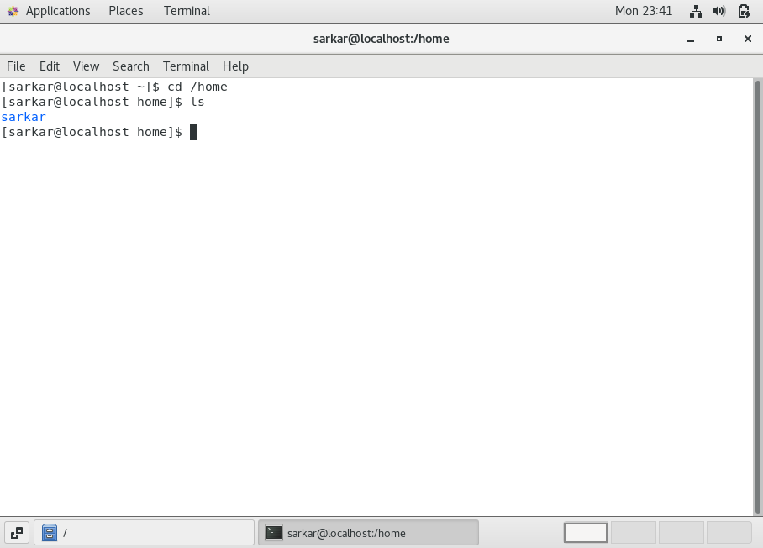

* Enter **cd ..** and hit **Enter** key [ *Note: here we have space after cd then use double dot*]
  + Check what happen and give screenshot?

Ans. – We get out from home and return to same root directory first page.

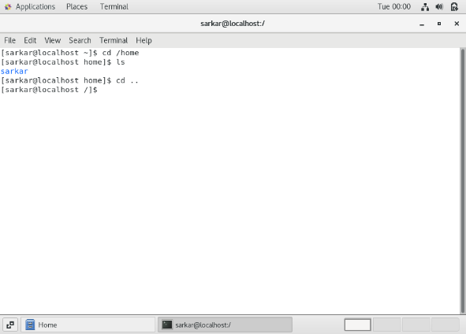

* Now enter **cd /var/www/html** and then type **cd** and hit **Enter** key
  + Explain what happen and give screenshot?

Ans. – Here we are giving wrong address so it is showing error as No such file or directory. And again by hitting cd command getout from root directory.

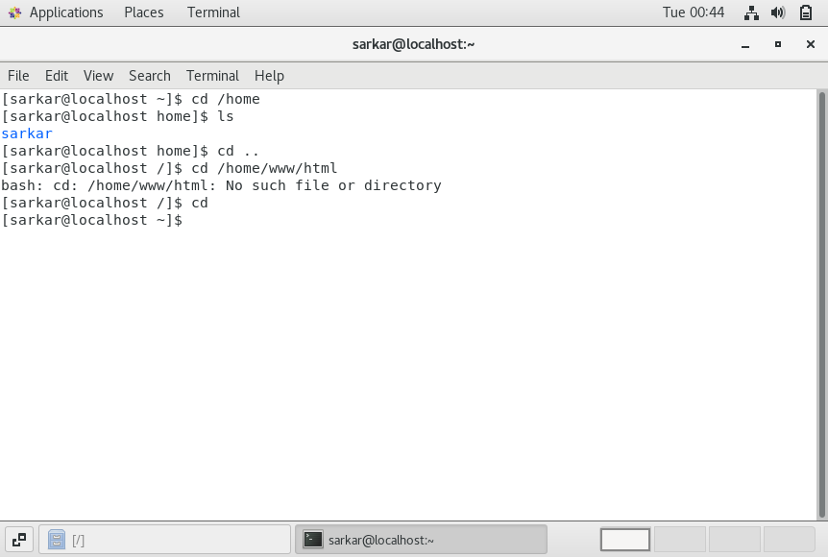

* Now type **cd /root** and then hit **Enter** key

Do **ls,** check any output we have on screen if yes then take screenshot?

Ans.- cd /root is invalid command here, and by clicking ls we get all the directories/folders present in linux.

- 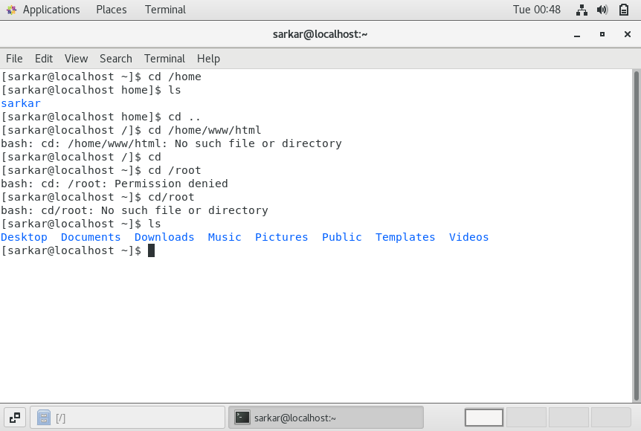

Assignment-4

Working with File Listing

* Go to **cd /etc** and type **ls**
  + Take screenshot and explain what files you have seeing?

Ans.- By entering cd/etc we again entered to root folder named etc. and by clicking ls we get the list of items present in that.

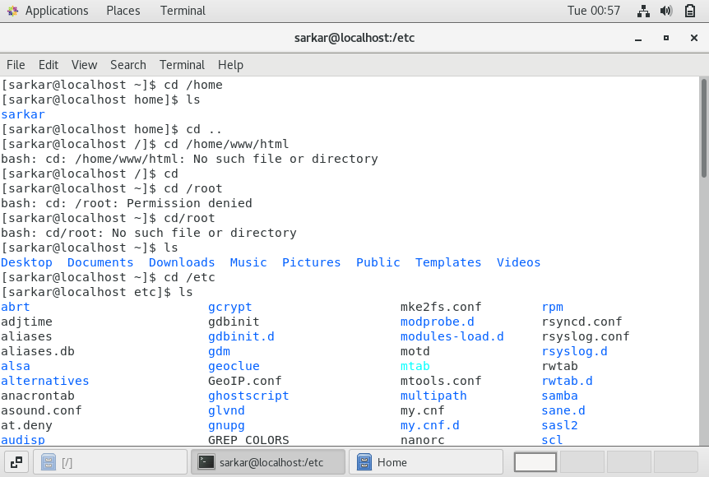

* Take screenshot and explain what different output you found compare to previous command you used?

Ans.- It shows all the software’s present.

* Then type **ls -al** and hit **Enter** key
  + Take screenshot and explain what new file or directory you found?

Ans-

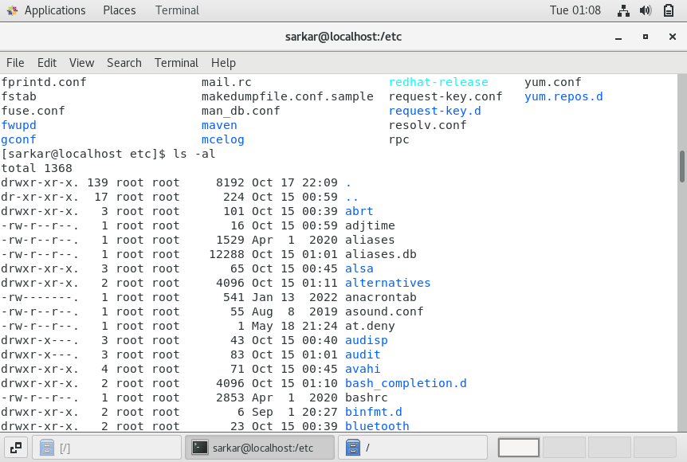

* Then use **ls -i** and hit **Enter** key
  + Now see what different output its shows and take screenshot?

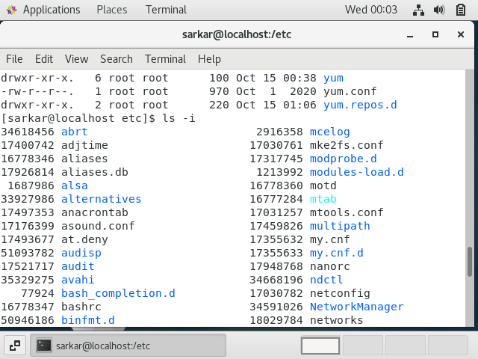

* Then use **ls –help** and see other options about **ls** command
  + Explore it and try with other attribute we can use with **ls** command

Ans- In my system its taking ls –help

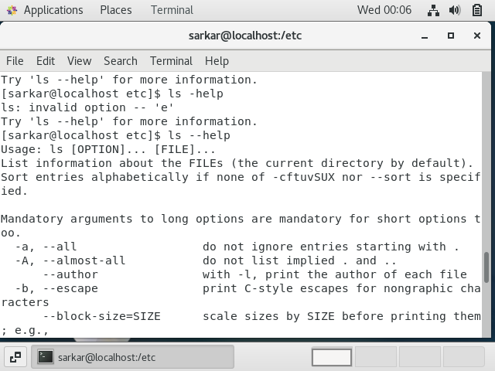

Assignment-5

Know where you are and where you working

*Here we use* ***pwd, cd and ls*** *as combine task to understand where you working on terminal and how you can switch from one directory to another one.*

* Open terminal after restart the linux

Check which location you working, type **pwd** and take screenshot

Ans- we are in home.

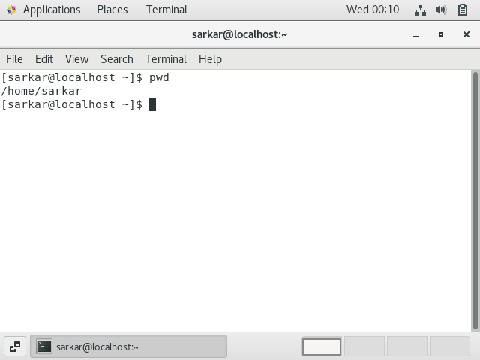

* Now use **cd /var** and hit **Enter** key
  + Do **ls,** and see what output comes, give screenshot?

Ans.- 